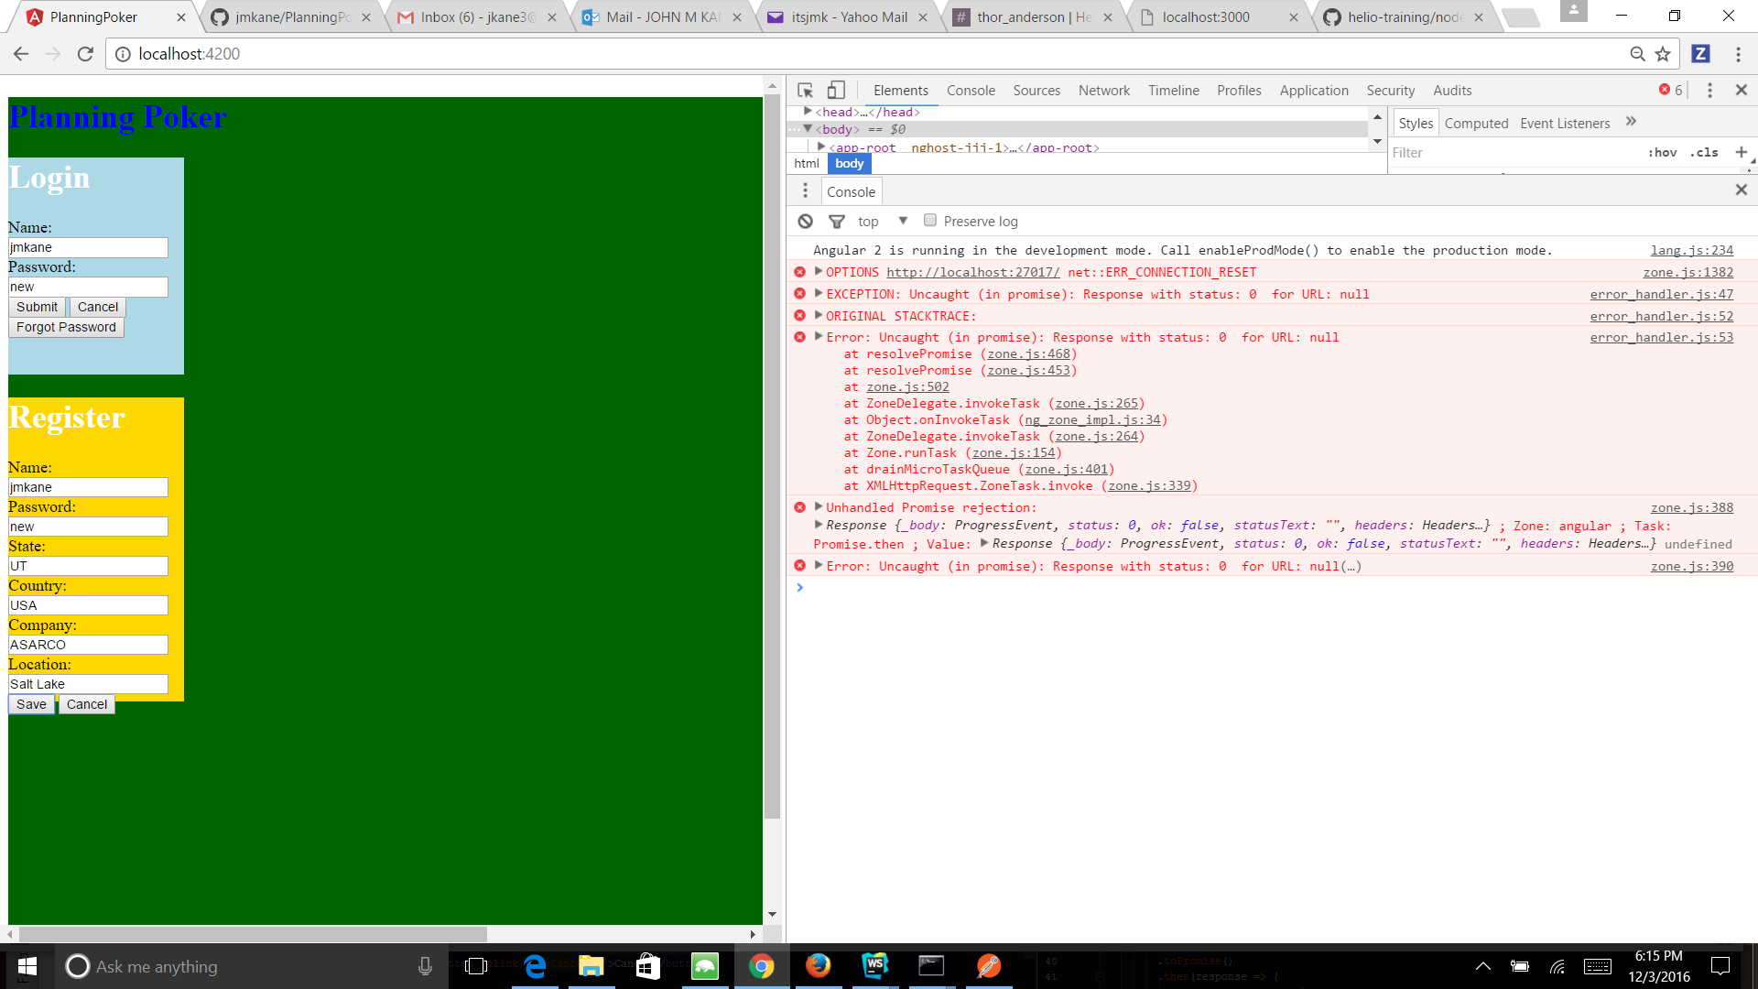

zone.js:1382 OPTIONS http://localhost:27017/ net::ERR_CONNECTION_RESETscheduleTask @ zone.js:1382ZoneDelegate.scheduleTask @ zone.js:245Zone.scheduleMacroTask @ zone.js:171(anonymous function) @ zone.js:1405send @ VM1771:3(anonymous function) @ xhr_backend.js:112Observable.subscribe @ Observable.js:56(anonymous function) @ toPromise.js:24ZoneAwarePromise @ zone.js:518toPromise @ toPromise.js:22LoginComponent.onRegisterUpdate @ login.component.ts:28_View_LoginComponent0._handle_click_86_0 @ LoginComponent.ngfactory.js:1238(anonymous function) @ view.js:403(anonymous function) @ dom_renderer.js:249(anonymous function) @ dom_events.js:26ZoneDelegate.invoke @ zone.js:232onInvoke @ ng_zone_impl.js:43ZoneDelegate.invoke @ zone.js:231Zone.runGuarded @ zone.js:128NgZoneImpl.runInnerGuarded @ ng_zone_impl.js:72NgZone.runGuarded @ ng_zone.js:235outsideHandler @ dom_events.js:26ZoneDelegate.invokeTask @ zone.js:265Zone.runTask @ zone.js:154ZoneTask.invoke @ zone.js:335

error_handler.js:47 EXCEPTION: Uncaught (in promise): Response with status: 0 for URL: nullErrorHandler.handleError @ error_handler.js:47next @ application_ref.js:272schedulerFn @ async.js:82SafeSubscriber.__tryOrUnsub @ Subscriber.js:223SafeSubscriber.next @ Subscriber.js:172Subscriber._next @ Subscriber.js:125Subscriber.next @ Subscriber.js:89Subject.next @ Subject.js:55EventEmitter.emit @ async.js:74onError @ ng_zone.js:119onHandleError @ ng_zone_impl.js:64ZoneDelegate.handleError @ zone.js:236Zone.runGuarded @ zone.js:131_loop_1 @ zone.js:412drainMicroTaskQueue @ zone.js:421ZoneTask.invoke @ zone.js:339

error_handler.js:52 ORIGINAL STACKTRACE:ErrorHandler.handleError @ error_handler.js:52next @ application_ref.js:272schedulerFn @ async.js:82SafeSubscriber.__tryOrUnsub @ Subscriber.js:223SafeSubscriber.next @ Subscriber.js:172Subscriber._next @ Subscriber.js:125Subscriber.next @ Subscriber.js:89Subject.next @ Subject.js:55EventEmitter.emit @ async.js:74onError @ ng_zone.js:119onHandleError @ ng_zone_impl.js:64ZoneDelegate.handleError @ zone.js:236Zone.runGuarded @ zone.js:131_loop_1 @ zone.js:412drainMicroTaskQueue @ zone.js:421ZoneTask.invoke @ zone.js:339

error_handler.js:53 Error: Uncaught (in promise): Response with status: 0 for URL: null

at resolvePromise (zone.js:468)

at resolvePromise (zone.js:453)

at zone.js:502

at ZoneDelegate.invokeTask (zone.js:265)

at Object.onInvokeTask (ng_zone_impl.js:34)

at ZoneDelegate.invokeTask (zone.js:264)

at Zone.runTask (zone.js:154)

at drainMicroTaskQueue (zone.js:401)

at XMLHttpRequest.ZoneTask.invoke (zone.js:339)ErrorHandler.handleError @ error_handler.js:53next @ application_ref.js:272schedulerFn @ async.js:82SafeSubscriber.__tryOrUnsub @ Subscriber.js:223SafeSubscriber.next @ Subscriber.js:172Subscriber._next @ Subscriber.js:125Subscriber.next @ Subscriber.js:89Subject.next @ Subject.js:55EventEmitter.emit @ async.js:74onError @ ng_zone.js:119onHandleError @ ng_zone_impl.js:64ZoneDelegate.handleError @ zone.js:236Zone.runGuarded @ zone.js:131_loop_1 @ zone.js:412drainMicroTaskQueue @ zone.js:421ZoneTask.invoke @ zone.js:339

zone.js:388 Unhandled Promise rejection: Response_body: ProgressEventheaders: Headersok: falsestatus: 0statusText: ""type: 3url: null__proto__: Body ; Zone: angular ; Task: Promise.then ; Value: Response {_body: ProgressEvent, status: 0, ok: false, statusText: "", headers: Headers…} undefinedconsoleError @ zone.js:388_loop_1 @ zone.js:417drainMicroTaskQueue @ zone.js:421ZoneTask.invoke @ zone.js:339

zone.js:390 Error: Uncaught (in promise): Response with status: 0 for URL: null(…)consoleError @ zone.js:390_loop_1 @ zone.js:417drainMicroTaskQueue @ zone.js:421ZoneTask.invoke @ zone.js:339

New error after change to Player_URL

zone.js:1382 OPTIONS http://localhost:3000/ scheduleTask @ zone.js:1382ZoneDelegate.scheduleTask @ zone.js:245Zone.scheduleMacroTask @ zone.js:171(anonymous function) @ zone.js:1405send @ VM1955:3(anonymous function) @ xhr_backend.js:112Observable.subscribe @ Observable.js:56(anonymous function) @ toPromise.js:24ZoneAwarePromise @ zone.js:518toPromise @ toPromise.js:22LoginComponent.onRegisterUpdate @ login.component.ts:28_View_LoginComponent0._handle_click_86_0 @ LoginComponent.ngfactory.js:1238(anonymous function) @ view.js:403(anonymous function) @ dom_renderer.js:249(anonymous function) @ dom_events.js:26ZoneDelegate.invoke @ zone.js:232onInvoke @ ng_zone_impl.js:43ZoneDelegate.invoke @ zone.js:231Zone.runGuarded @ zone.js:128NgZoneImpl.runInnerGuarded @ ng_zone_impl.js:72NgZone.runGuarded @ ng_zone.js:235outsideHandler @ dom_events.js:26ZoneDelegate.invokeTask @ zone.js:265Zone.runTask @ zone.js:154ZoneTask.invoke @ zone.js:335

localhost/:1 XMLHttpRequest cannot load http://localhost:3000/. Response to preflight request doesn't pass access control check: No 'Access-Control-Allow-Origin' header is present on the requested resource. Origin 'http://localhost:4200' is therefore not allowed access. The response had HTTP status code 404.

error_handler.js:47 EXCEPTION: Uncaught (in promise): Response with status: 0 for URL: nullErrorHandler.handleError @ error_handler.js:47next @ application_ref.js:272schedulerFn @ async.js:82SafeSubscriber.__tryOrUnsub @ Subscriber.js:223SafeSubscriber.next @ Subscriber.js:172Subscriber._next @ Subscriber.js:125Subscriber.next @ Subscriber.js:89Subject.next @ Subject.js:55EventEmitter.emit @ async.js:74onError @ ng_zone.js:119onHandleError @ ng_zone_impl.js:64ZoneDelegate.handleError @ zone.js:236Zone.runGuarded @ zone.js:131_loop_1 @ zone.js:412drainMicroTaskQueue @ zone.js:421ZoneTask.invoke @ zone.js:339

error_handler.js:52 ORIGINAL STACKTRACE:ErrorHandler.handleError @ error_handler.js:52next @ application_ref.js:272schedulerFn @ async.js:82SafeSubscriber.__tryOrUnsub @ Subscriber.js:223SafeSubscriber.next @ Subscriber.js:172Subscriber._next @ Subscriber.js:125Subscriber.next @ Subscriber.js:89Subject.next @ Subject.js:55EventEmitter.emit @ async.js:74onError @ ng_zone.js:119onHandleError @ ng_zone_impl.js:64ZoneDelegate.handleError @ zone.js:236Zone.runGuarded @ zone.js:131_loop_1 @ zone.js:412drainMicroTaskQueue @ zone.js:421ZoneTask.invoke @ zone.js:339

error_handler.js:53 Error: Uncaught (in promise): Response with status: 0 for URL: null

at resolvePromise (zone.js:468)

at resolvePromise (zone.js:453)

at zone.js:502

at ZoneDelegate.invokeTask (zone.js:265)

at Object.onInvokeTask (ng_zone_impl.js:34)

at ZoneDelegate.invokeTask (zone.js:264)

at Zone.runTask (zone.js:154)

at drainMicroTaskQueue (zone.js:401)

at XMLHttpRequest.ZoneTask.invoke (zone.js:339)ErrorHandler.handleError @ error_handler.js:53next @ application_ref.js:272schedulerFn @ async.js:82SafeSubscriber.__tryOrUnsub @ Subscriber.js:223SafeSubscriber.next @ Subscriber.js:172Subscriber._next @ Subscriber.js:125Subscriber.next @ Subscriber.js:89Subject.next @ Subject.js:55EventEmitter.emit @ async.js:74onError @ ng_zone.js:119onHandleError @ ng_zone_impl.js:64ZoneDelegate.handleError @ zone.js:236Zone.runGuarded @ zone.js:131_loop_1 @ zone.js:412drainMicroTaskQueue @ zone.js:421ZoneTask.invoke @ zone.js:339

zone.js:388 Unhandled Promise rejection: Response_body: ProgressEventheaders: Headersok: falsestatus: 0statusText: ""type: 3url: null__proto__: Body ; Zone: angular ; Task: Promise.then ; Value: Response {_body: ProgressEvent, status: 0, ok: false, statusText: "", headers: Headers…} undefinedconsoleError @ zone.js:388_loop_1 @ zone.js:417drainMicroTaskQueue @ zone.js:421ZoneTask.invoke @ zone.js:339

zone.js:390 Error: Uncaught (in promise): Response with status: 0 for URL: null(…)consoleError @ zone.js:390_loop_1 @ zone.js:417drainMicroTaskQueue @ zone.js:421ZoneTask.invoke @ zone.js:339